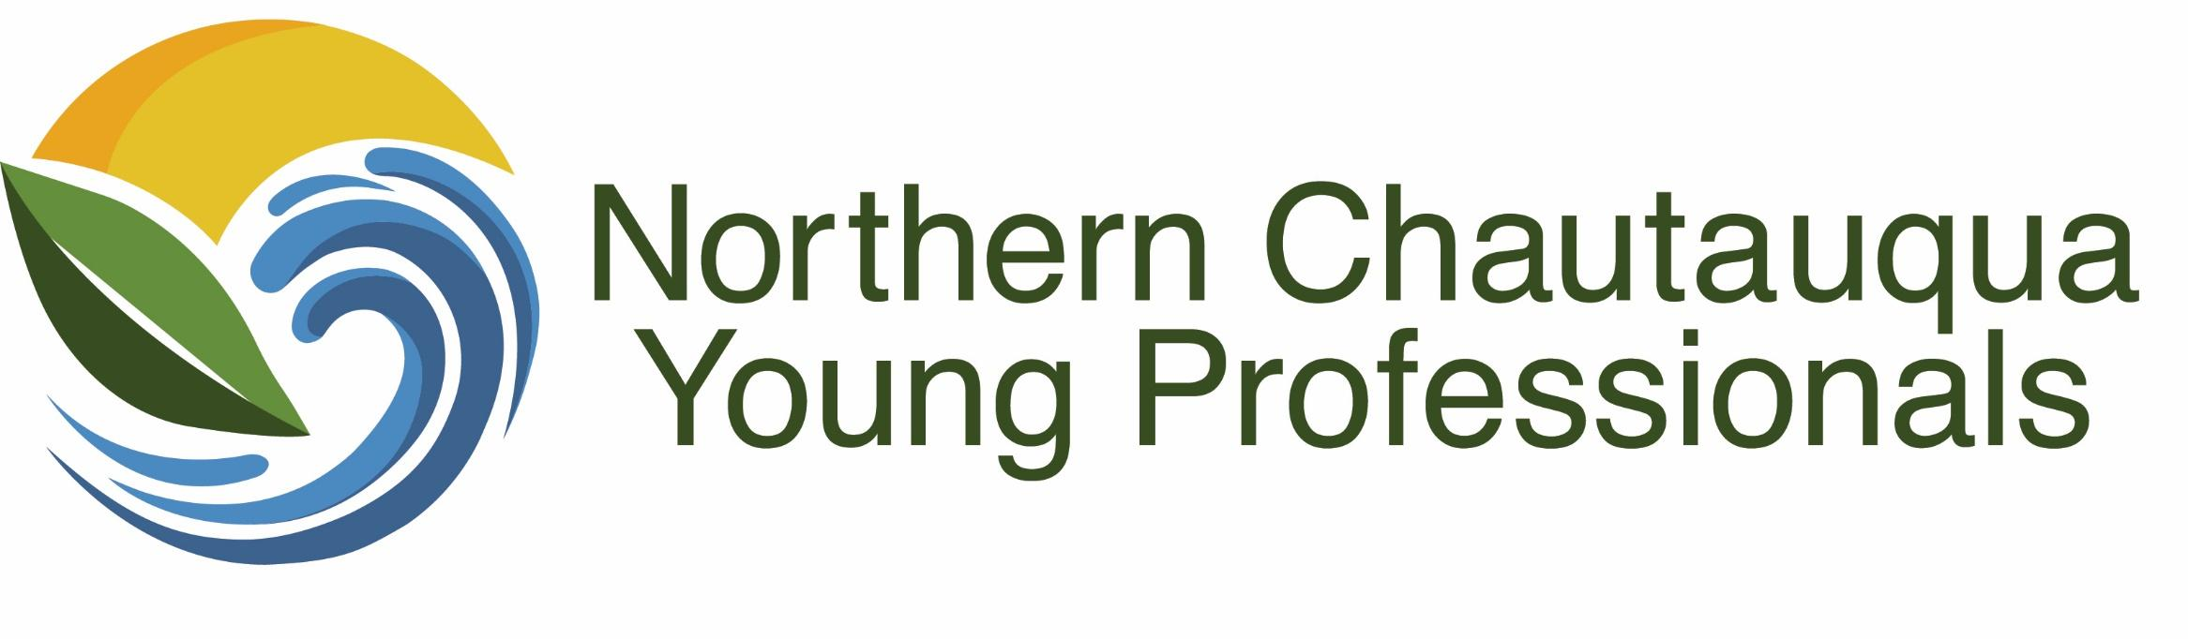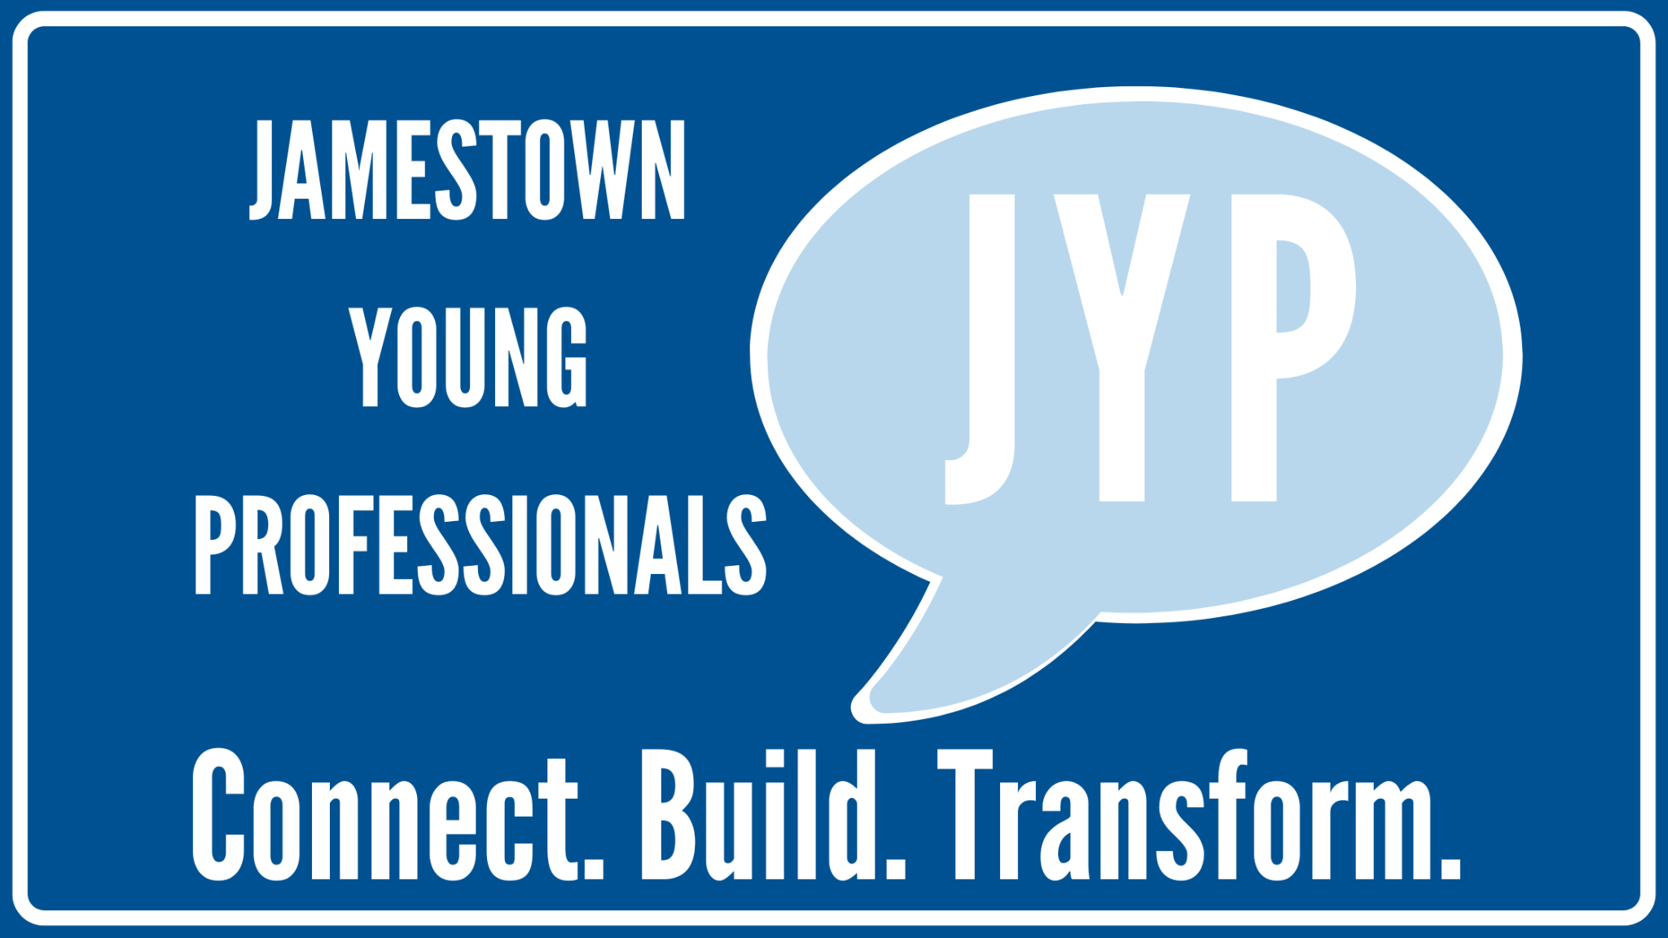

To Whom It May Concern:

We are reaching out to you on behalf of the Northern Chautauqua Young Professionals and Jamestown Young Professionals about a sponsorship opportunity for an upcoming Marketing Panel Discussion and Networking event hosted by NCYP & JYP. This event is on Wednesday, May 3rd at the Athenaeum Hotel at Chautauqua Institution from 2:00 pm - 6:00 pm.
The hope is that this event will engage businesses of all sizes, get more young professionals involved in their community, and connect them to their respective professional networks. The marketing panel will take place from 2:30 - 4:00, featuring four local marketing professionals that will speak on their work followed by a Q&A session. Everyone will then be welcomed to a networking session at 4 pm immediately following the panel.
We invite you and your organization to sponsor this event so we can offer this event free of charge for all attendees. We need your help in making this possible and hope you will consider one of the sponsorship levels below:
$500 - PLATINUM
- Logo included on all promotional materials (website, press release, flyers, etc.)
- Thank you and tagging on JYP & NCYP social media pages and posts.
- Brief speaking opportunity at event

$250 - GOLD
- Logo included on all promotional materials (website, press release, flyers, etc.)
- Thank you and tagging on JYP & NCYP social media pages and posts.

$150 - SILVER
- Logo included on all promotional materials.

Please let us know if you are interested in supporting this event by contacting either Monica Simpson simpsonm@chqgov.com or Lindsey Goold lrensel@uwayscc.org by Friday, April 14th. Thank you so much for your consideration!

Thank You!
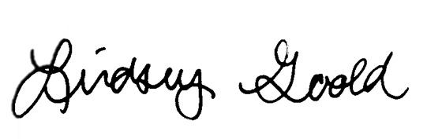
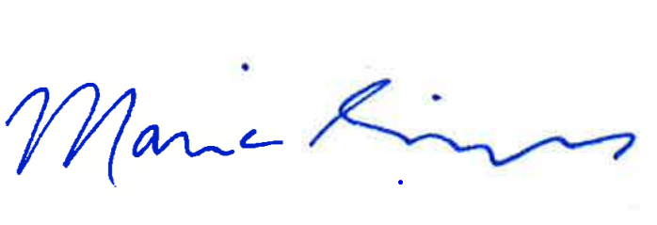

Lindsey Goold Monica Simpson
Jamestown Young Professionals North County Young Professionals

